Becoming a WLLR website member
To join the West Lancashire Light Railway as a website member, first open the website https://www.westlancsrailway.org in your browser.
Go to the menu, for example by scrolling down to the green ‘Visitor Information’ block and clicking on the arrow in the light green circle.
Then scroll down to the bottom of the page and click on ‘Members’.
This will take you to the Members’ Section, where you will see that you need to be a member of the Railway to access the member pages. If you’re not a member, follow the instructions to download and complete the application form.
Once you have your Railway membership confirmed, click in the Log In box next to where it says ‘You can log in here:’
After a moment or two this ‘Log In’ dialog will appear:
Now click on the blue ‘Sign up’ words.
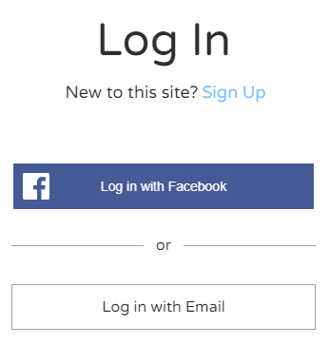

After a moment or two you will see the ‘Sign Up’ dialog.
Select the ‘Sign up with email’ option.
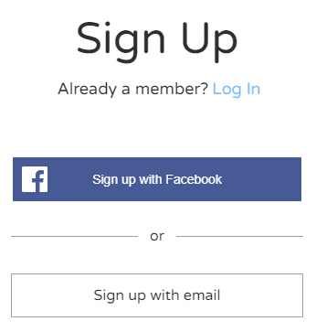

The ‘Sign Up’ dialog changes and presents two input fields.
In the Email field type the email address you wish to use.
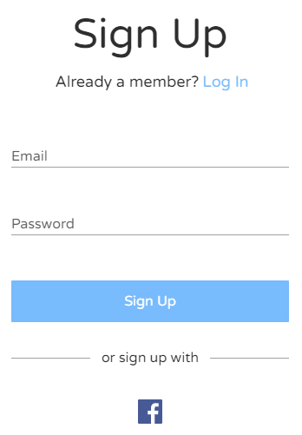
Then type a password that you will remember, and select the blue ‘Sign Up’ button.

After a moment or two you will get this ‘success’ message.
Select the OK button and you will be taken back to the Members’ page of the website whilst your application is processed.
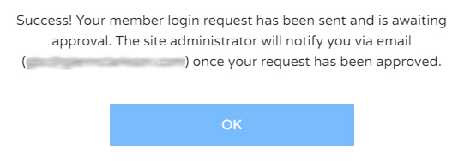

In due course you will receive an email notification that your membership request has been approved by the site administrator.
It will ask you to click on a link to confirm your email address. This will take you to the front page of westlancsrailway.org. Go to the menu (as above) and click on ‘Members’. This will take you to the members’ page, where you can log in to the members’ pages using your email and password.

